Repair Café Risk assessment

Name of Repair Café: St Ives Repair Cafe Date of event: 26th October 2024

Risk No | What are the hazards? | Who might be harmed and how? | What are you already doing? | Do you need to do anything else to control this risk?
1 | Faulty electrical equipment or improper handling of electrical devices. | Volunteers and visitors, especially those handling or near electrical repairs, could suffer injuries or fatal accidents. | Using only well-maintained equipment, providing basic electrical safety training to volunteers. | Regular equipment checks, clear instructions for electrical safety, and designated areas for electrical repairs.
2 | Sharp tools like scissors, knives, or broken parts of items being repaired. | Volunteers and visitors could get cuts or lacerations. | Using safety equipment (like gloves), ensuring tools are stored safely when not in use. | Have clear tool-handling instructions, maintain a first-aid kit, and have clear safety protocols.
3 | Cables, tools, or other objects left on the floor, uneven surfaces. | Anyone in the area could trip, potentially causing injury. | Keeping areas clear, using cable covers for wires running where necessary. | Regular monitoring of spaces to ensure pathways are clear, highlighting potential trip hazards.
4 | Overloaded power outlets, malfunctioning equipment, flammable materials. | All attendees in case of a fire. | Regular electrical checks, having fire extinguishers and smoke detectors in place. | Fire safety training for volunteers, clear evacuation procedures.
5 | Use of glues, solvents, or other hazardous substances. | Volunteers and visitors could suffer from skin or respiratory problems due to exposure. | Using less harmful substances, providing protective gear. | Proper storage and labeling of chemicals, ventilation in areas where chemicals are used.
6 | Too many devices plugged into a single outlet, leading to potential overload or short circuits. | Risk of fire or equipment damage, potentially harming anyone nearby. | Using power strips with surge protectors, limiting the number of devices per outlet. | Regular checks on power usage, clear instructions on maximum load per outlet.

Risk Assessment carried out by: Elise Langley Signature: 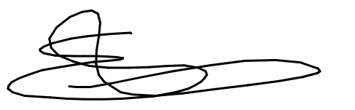 Date: 15 October 2024

